SOFTWARE TESTING – TUTORIAL 2
TEST PLAN+RTM

TC01 –Valid Registration
Steps:
- Open the Automation Exercise website.
- Click on the Signup / Login option.
- Enter a valid name.
- Enter a valid email address.
- Click on the Signup button.
- Complete the registration details.
- Verify that the account is created successfully.
Expected Result: User should be registered successfully.
Actual Result: User was registered successfully.
Status: PASS
Screenshot:
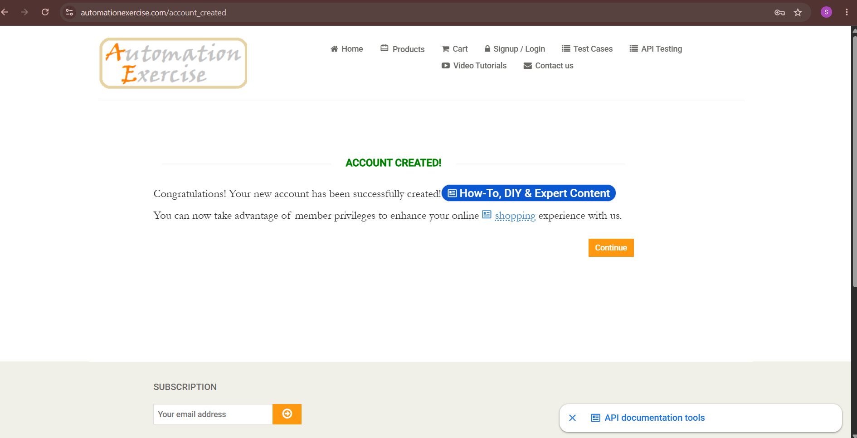

TC02 – Invalid Registration
Steps:
- Open the Automation Exercise website.
- Click on the Signup / Login option.
- Locate the New User Signup! section.
- Enter Shivyy in the Name field.
- Enter shiviydv.sou07 in the Email Address field.
- Click on the Signup button.
- Verify the validation/error message.
Expected Result: Invalid email address should not be accepted and an appropriate validation message should be displayed.
Actual Result: Invalid email address was not accepted and the validation message was displayed.
Status: PASS
Screenshot:
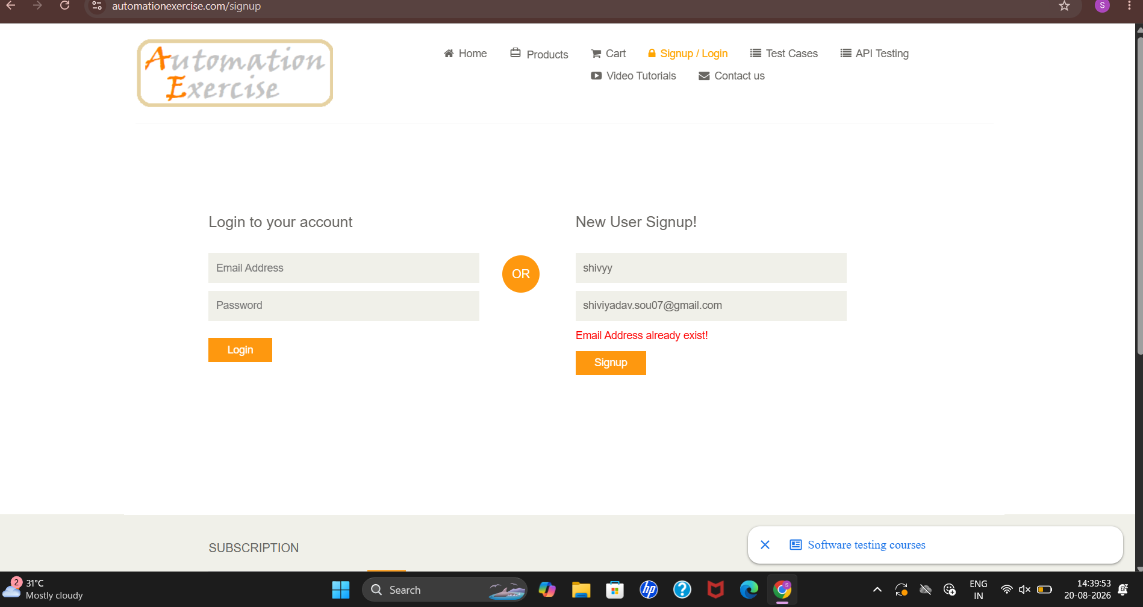

TC03 – Registration with Existing Email
Test Case: Verify that the user cannot register using an already registered email address.
Steps:
- Open the Automation Exercise website.
- Click on the Signup / Login option.
- Locate the New User Signup! section.
- Enter Shivyy in the Name field.
- Enter an already registered email address.
- Click on the Signup button.
- Verify the error message.
Expected Result: Registration should not proceed and an appropriate error message should be displayed.
Actual Result: Registration did not proceed and the error message was displayed.
Status: PASS

TC04 – Valid Login
Test Case: Verify that the user can log in successfully with valid credentials.
Steps:
- Open the Automation Exercise website.
- Click on the Signup / Login option.
- Locate the Login to your account section.
- Enter a valid registered email address.
- Enter the valid password.
- Click on the Login button.
- Verify that the user is logged in successfully.
Expected Result: User should be logged in successfully.
Actual Result: User logged in successfully.
Status: PASS
Screenshot: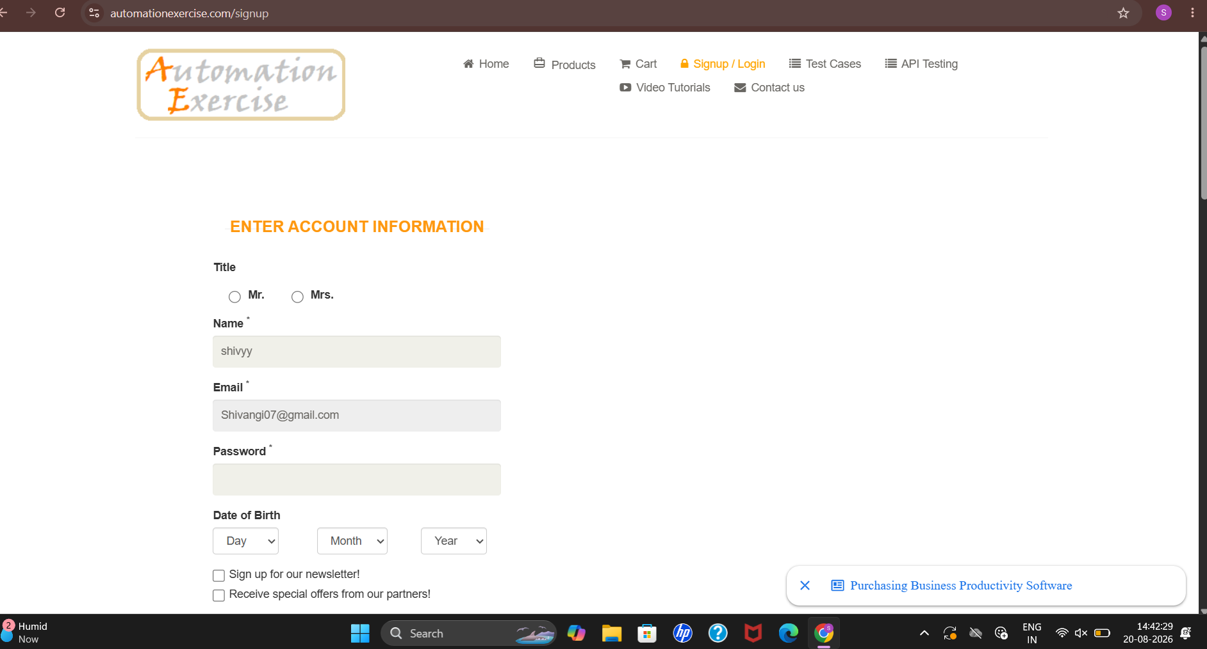
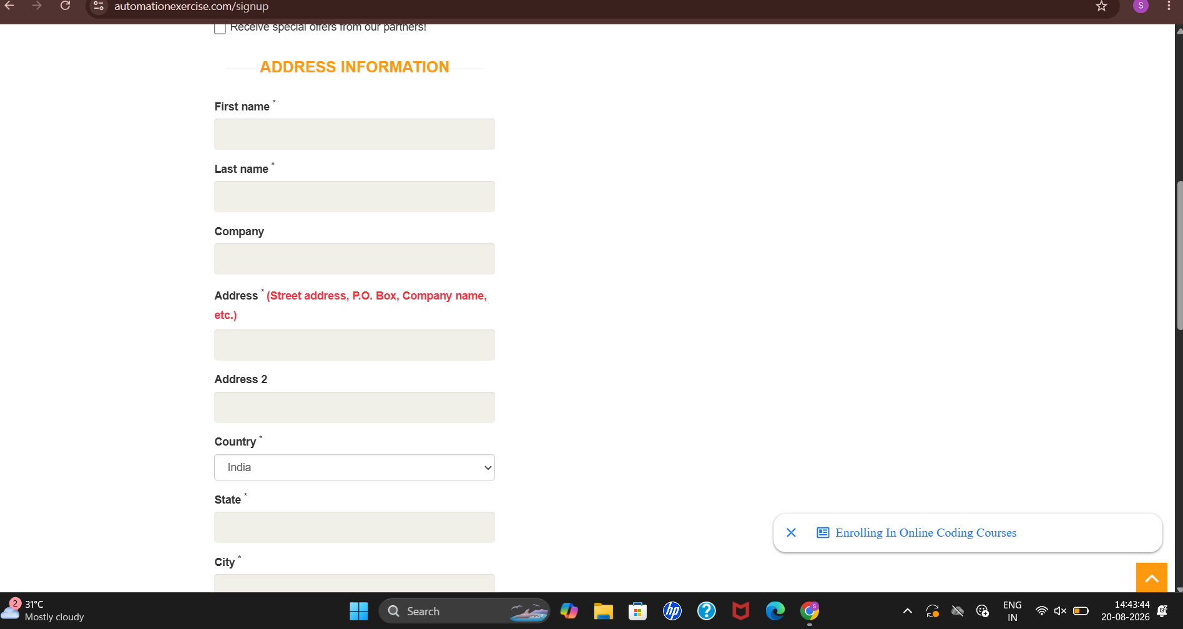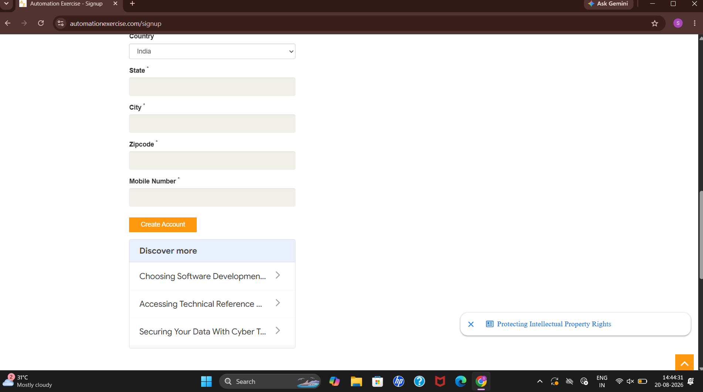

TC05 – Invalid Login
Test Case: Verify that the user cannot log in with invalid credentials.
Steps:
- Open the Automation Exercise website.
- Click on the Signup / Login option.
- Locate the Login to your account section.
- Enter an invalid email address.
- Enter an incorrect password.
- Click on the Login button.
- Verify the error message.
Expected Result: User should not be logged in and an appropriate error message should be displayed.
Actual Result: User was not logged in and the error message was displayed.
Status: PASS
Screenshot:
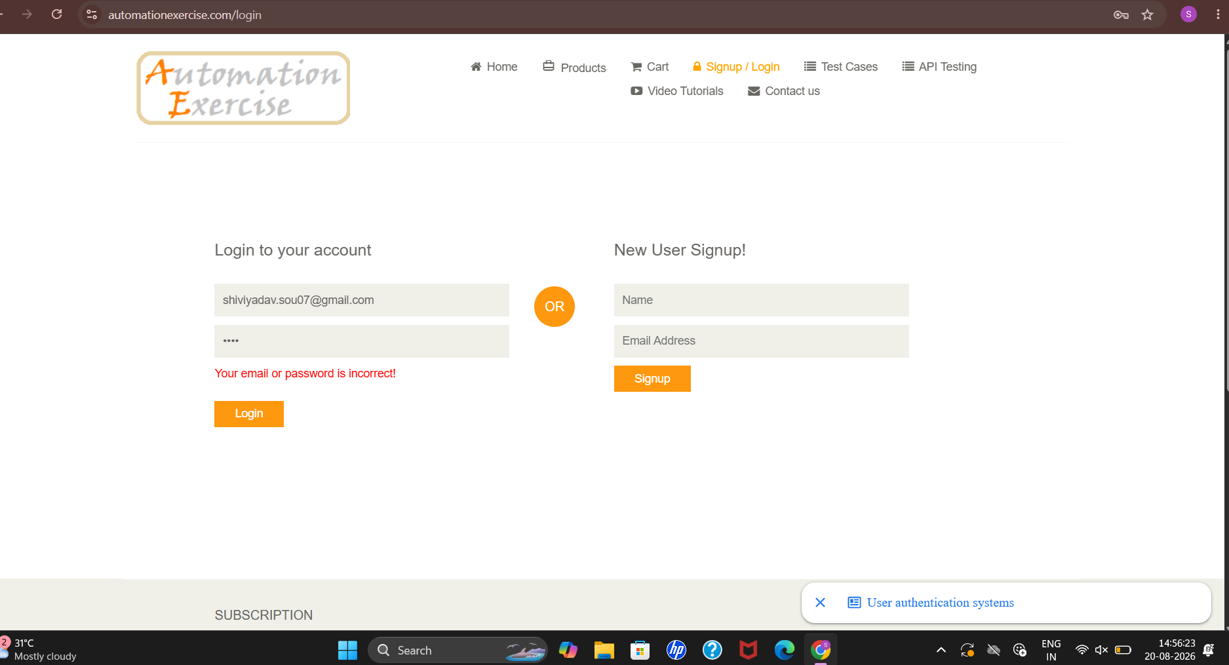

TC06 – Invalid Password
Test Case: Verify that the user cannot log in with an incorrect password.
Steps:
- Open the Automation Exercise website.
- Click on the Signup / Login option.
- Locate the Login to your account section.
- Enter a valid registered email address.
- Enter an incorrect password.
- Click on the Login button.
- Verify the error message.
Expected Result: User should not be logged in and an appropriate error message should be displayed.
Actual Result: User was not logged in and the error message was displayed.
Status: PASS
Screenshot:

TC07 – Blank Username
Test Case: Verify that the user cannot log in when the Email Address field is left blank.
Steps:
- Open the Automation Exercise website.
- Click on the Signup / Login option.
- Locate the Login to your account section.
- Leave the Email Address field blank.
- Enter a valid password in the Password field.
- Click on the Login button.
- Verify the validation message.
Expected Result: User should not be logged in and the Email Address field should show a validation message.
Actual Result: User was not logged in and the Email Address field showed a validation message.
Screenshot;
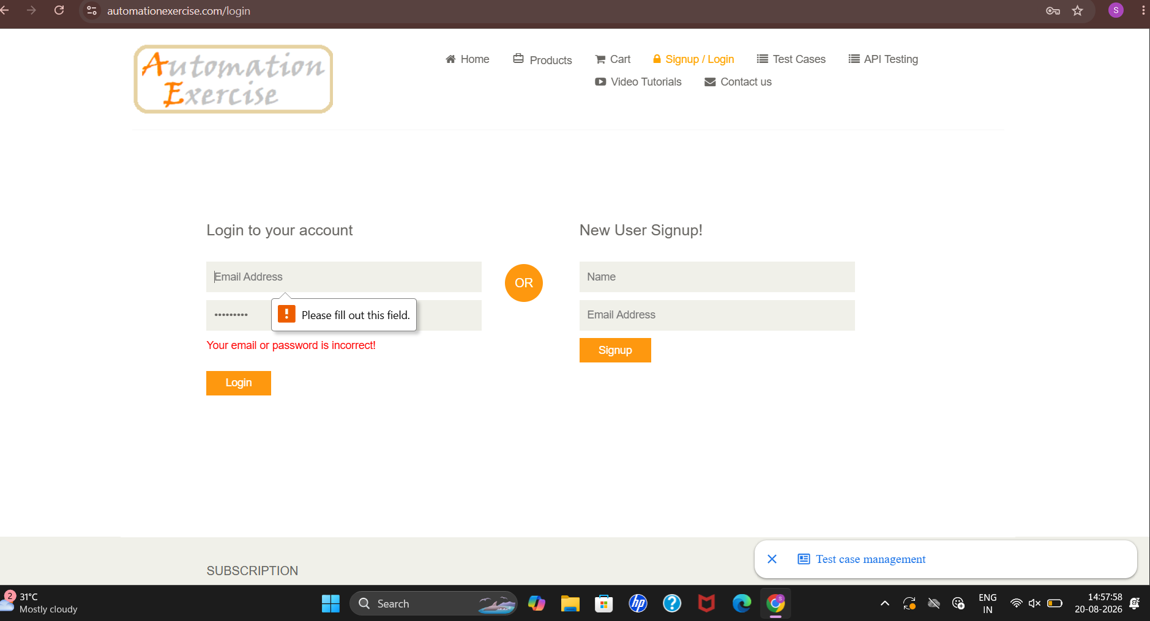

TC08 – Verify Logout Functionality
Test Case: Verify that the user can log out successfully.
Steps:
- Open the Automation Exercise website.
- Click on the Signup / Login option.
- Enter a valid registered email address.
- Enter the valid password.
- Click on the Login button.
- Verify that the user is logged in successfully.
- Click on the Logout option.
- Verify that the user is logged out successfully.
Expected Result: User should be logged out successfully and the Login page should be displayed.
Actual Result: User was logged out successfully and the Login page was displayed.
Status: PASS
Screenshot:
